Teacher – Mrs.Volynskaya MATH MAGAZINE PROJECT 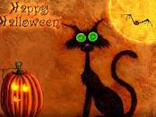 Name_______________
You will be creating your own math magazine for this project. Your magazine needs to include the following:
- Creative Cover with an original title; pictures
- “Spooky” Lesson on any math topic covered this or last school year.
Your lesson should include: a) Vocabulary /Definitions. B) “How to”- explanation/ procedures/ or rules. C) 2 examples with work shown. D) 1 word problems for readers to solve. (Answers should be on answer page).
3. Article of How math (your topic) is used in the real world. Your story should be written in paragraph form. Include 2 word problems with this component. (Answers should be on answer page).
4.Survey – Create a survey – ask students, family or friends how Hollowing is celebrated in their native country OR how math is used in real life (Must survey at least 10 people) .Results of your survey should be presented in a chart.
5. Spooky Fun Page- can include word search, puzzles, sudoku’s, jokes, games, etc.
6. Answer Page- All answers for problems you created must be included.
7. “About the Author” page. You may include a picture of yourself if you like.
Magazines must be typed. You may in addition, do this as a power point presentation. 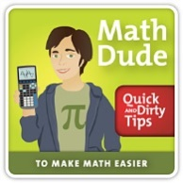 READ GRADING RUBRICK!!!
DUE DATE: October 26

