Mrs.Volynskaya Study Guide Methods for Solving Limits with Calculator
Method 1: Graphically Ex. $\lim_{x→1}{\frac{x^{2}+3x-4}{x-1}}$
Put equation into graph: $y=______________$
- Use the TRACE button to evaluate
for Y given x = ____, ____, ____

y = ____, ____, ____
Method 2: Numerically Ex. $\lim_{x→1}{\frac{x^{2}+3x-4}{x-1}}$
Put equation into: $y=______________$
Set Table: push 2nd window (TBLSET)
TABLE SETUP
TblStart = ____
= ____
Indpnt: Auto
Depend: Auto
Table: push 2nd Graph (TABLE)
Look at table to evaluate the Limit = ________
Method 3: Analytically
- Plug the x value being approached into the given function.
- If your result exists then that is your solution.
- If your result doesn’t exist and is not $\frac{0}{0}$ then the limit does not exist.
- If your result doesn’t exist and is $\frac{0}{0}$ then the limit exists.
- The expression needs to be simplified to find the limit.
- After you simplify re-plug in the x value to find the solution.

Mrs.Volynskaya Evaluating Limits by Viewing the Graph of F(x) Name___________
- Use the Graph of f below to evaluate each limit:
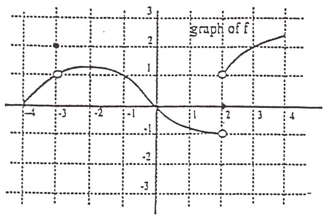
- $\lim_{x→{-3}^{-}}{f\left(x\right)}$ b. $\lim_{x→{-3}^{+}}{f\left(x\right)}$ c. $\lim_{x→-3}{f\left(x\right)}$
d. $\lim_{x→2^{-}}{f\left(x\right)}$ e. $\lim_{x→2^{+}}{f\left(x\right)}$ f. $\lim_{x→2}{f\left(x\right)}$

- Use the Graph of g below to evaluate each limit:
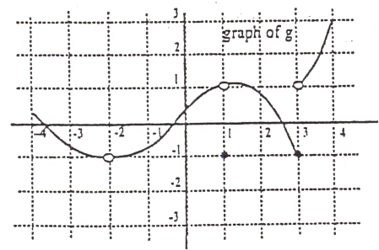
- $\lim_{x→-2}{g\left(x\right)}$ b. $\lim_{x→1}{g\left(x\right)}$ c. $g\left(1\right)$
d. $\lim_{x→3^{-}}{g\left(x\right)}$ e. $\lim_{x→3^{+}}{g\left(x\right)}$ f. $\lim_{x→3}{g\left(x\right)}$
- Use the graph to evaluate each limit:

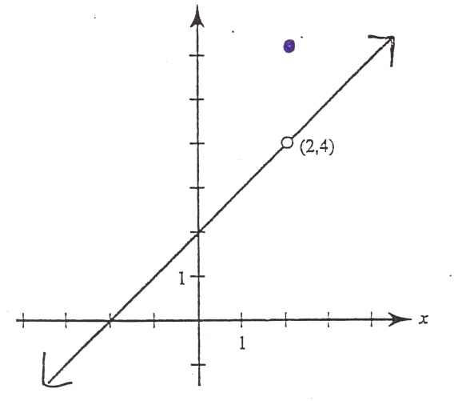
- $\lim_{x→0}{f\left(x\right)}$
- $\lim_{x→2}{f\left(x\right)}$
- $f\left(2\right)$
- Use the graph to evaluate each limit:
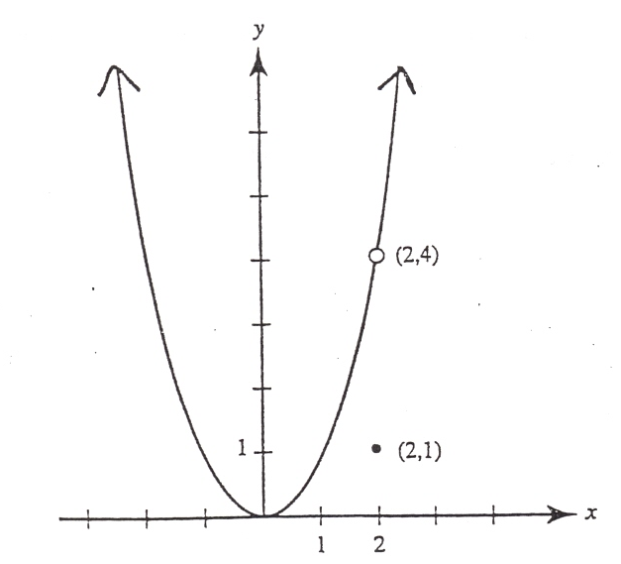
- $\lim_{x→0}{f\left(x\right)}$

- $\lim_{x→2}{f\left(x\right)}$

- $f\left(2\right)$

- Use the graph to evaluate each limit:
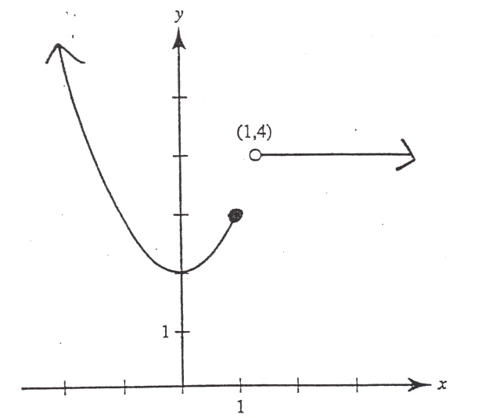
- $\lim_{x→3}{f\left(x\right)}$ b. $\lim_{x→0}{f\left(x\right)}$
c. $\lim_{x→1}{f\left(x\right)}$ d. $\lim_{x→1^{-}}{f\left(x\right)}$
e. $\lim_{x→1^{+}}{f\left(x\right)}$ f. $f\left(1\right)$

- Use the graph to evaluate each limit:
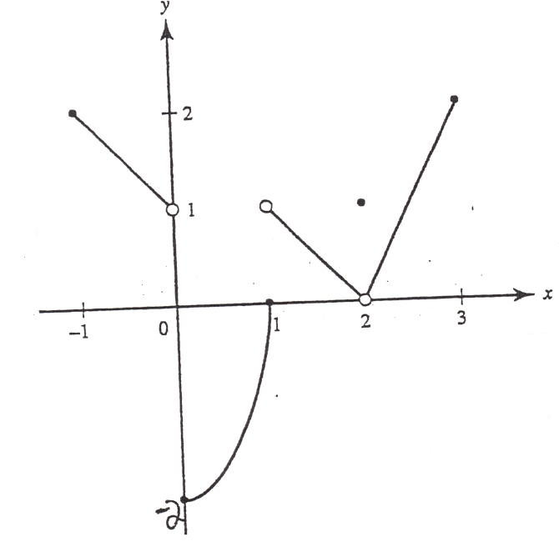
- $\lim_{x→0^{-}}{f\left(x\right)}$ b. $\lim_{x→0^{+}}{f\left(x\right)}$ c. $\lim_{x→0}{f\left(x\right)}$
d. $\lim_{x→1^{-}}{f\left(x\right)}$ e. $\lim_{x→1^{+}}{f\left(x\right)}$ f. $\lim_{x→1}{f\left(x\right)}$
g. $\lim_{x→2^{-}}{f\left(x\right)}$ h. $\lim_{x→2^{+}}{f\left(x\right)}$ i. $\lim_{x→2}{f\left(x\right)}$
j. $f\left(2\right)$ k. $f\left(0\right)$
Mrs.Volynskaya FIND the following limits Name____________
- $\lim_{x→3}{\frac{x^{2}-2x-3}{x-3}}$ 2. $\lim_{x→-3}{\frac{x^{2}+4x-4}{x-3}}$

3.$\lim_{c→0}{c^{2}+1}$ 4. $\lim_{u→1}{\frac{u^{2}+6u-7}{u^{2}-1}}$

5. $\lim_{t→2}{\frac{t^{2}-5t+6}{t^{2}-t-2}}$ 6. $\lim_{x→2}{\frac{x^{2}+x-6}{x+2}}$

7. $\lim_{x→2}{\frac{x^{3}-8}{x-2}}$ 8. $\lim_{x→0}{\frac{x^{3}-16x}{x^{2}+4x}}$

9. $\lim_{x→-3}{\frac{{2x}^{2}+5x-3}{x+3}}$ 10. $\lim_{x→2}{x^{3}}$

