Mrs.Volynskaya AP Calculus Prerequisite Topics
Your Calculus Textbook includes Preparation for Calculus chapters P.1-P.4 (pp1-44) which you will review by yourself to be ready for the Diagnostic Test and to feel comfortable and confident while learning Calculus.
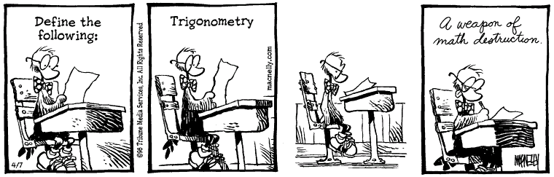

What You should know entering AP Calculus course:
- How to write equations of lines in slope-intercept, point-slope, and standard forms
- How to write equations of parallel and perpendicular lines
- How to find the domain and range of a function, including piecewise functions
- How to evaluate the composition of functions
- Solve quadratic equations.
- How to use properties of logarithms to solve equations
- How to find the inverse of a function
- How to find vertical and horizontal asymptotes and holes in the graphs of rational functions
- How to solve trigonometric equations, using exact values from the unit circle
- How to find the six standard trigonometric values given one of them
- How to manipulate trig functions using identities

